1. Line Chart

X axis – Year with month, Y axis – Death count, Legends list of states.

**Link :** <https://public.tableau.com/app/profile/aarthi.subramanian/viz/Task4_17146422821190/Task2_4?publish=yes>

Below screen-prints x axis in months so its difficult to interpret

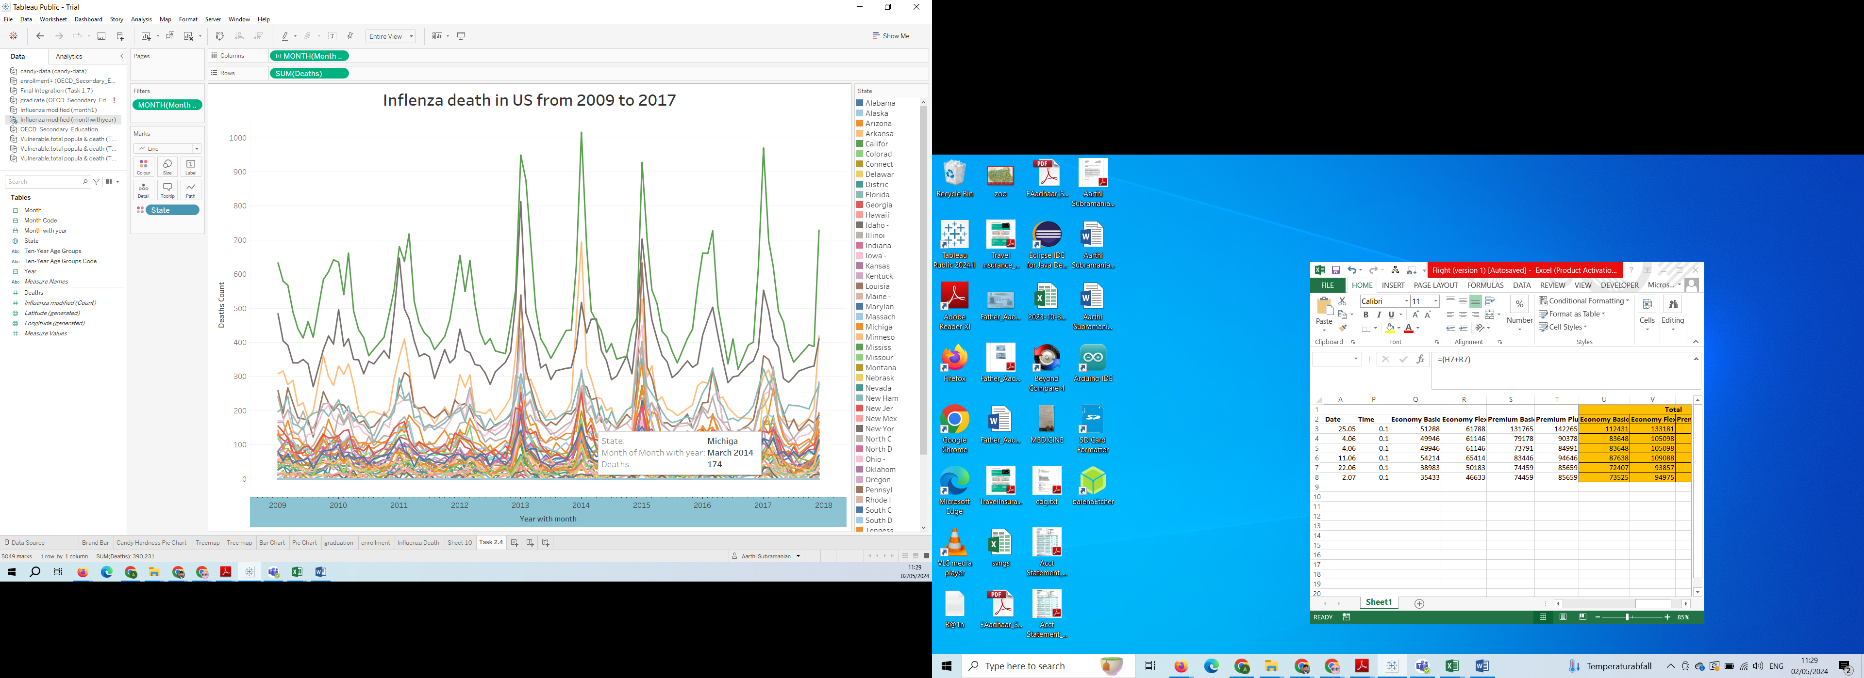

Below screen-print x axis in years 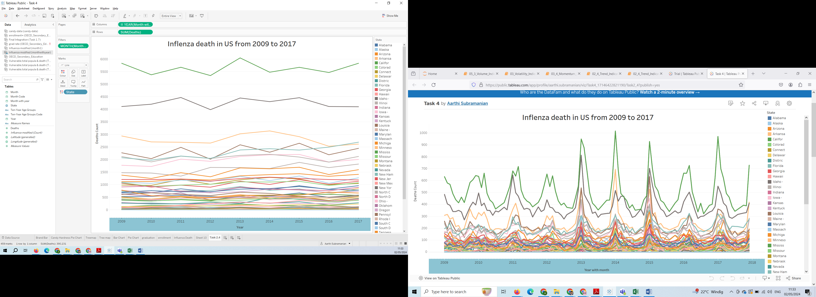

3. Seasonality On and Off Screen-prints

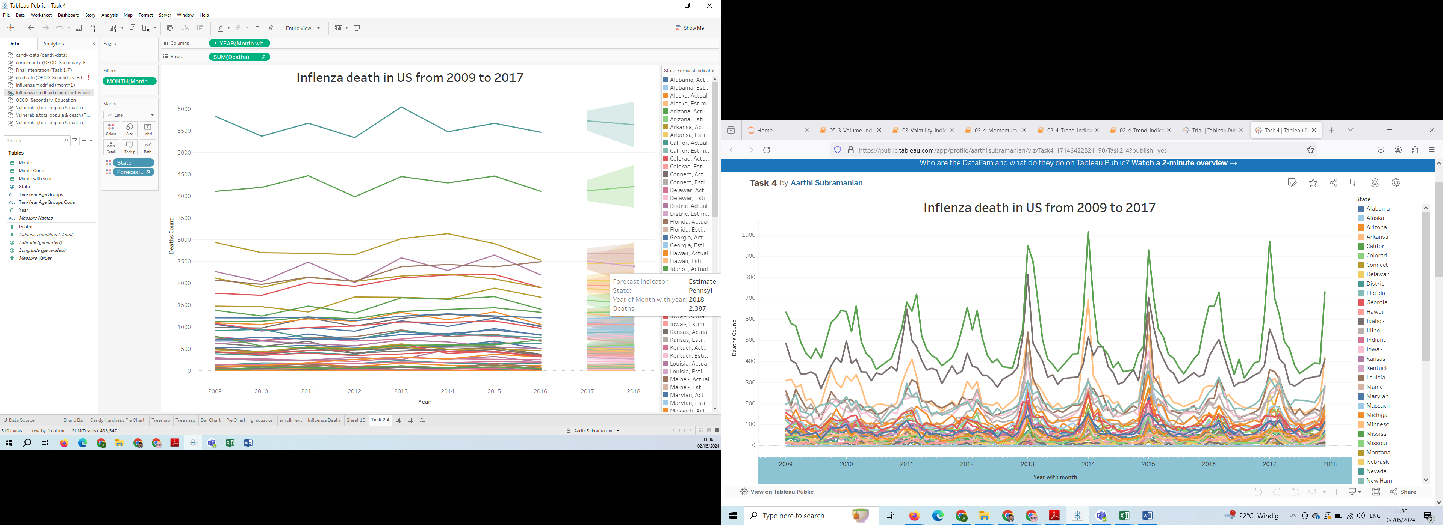

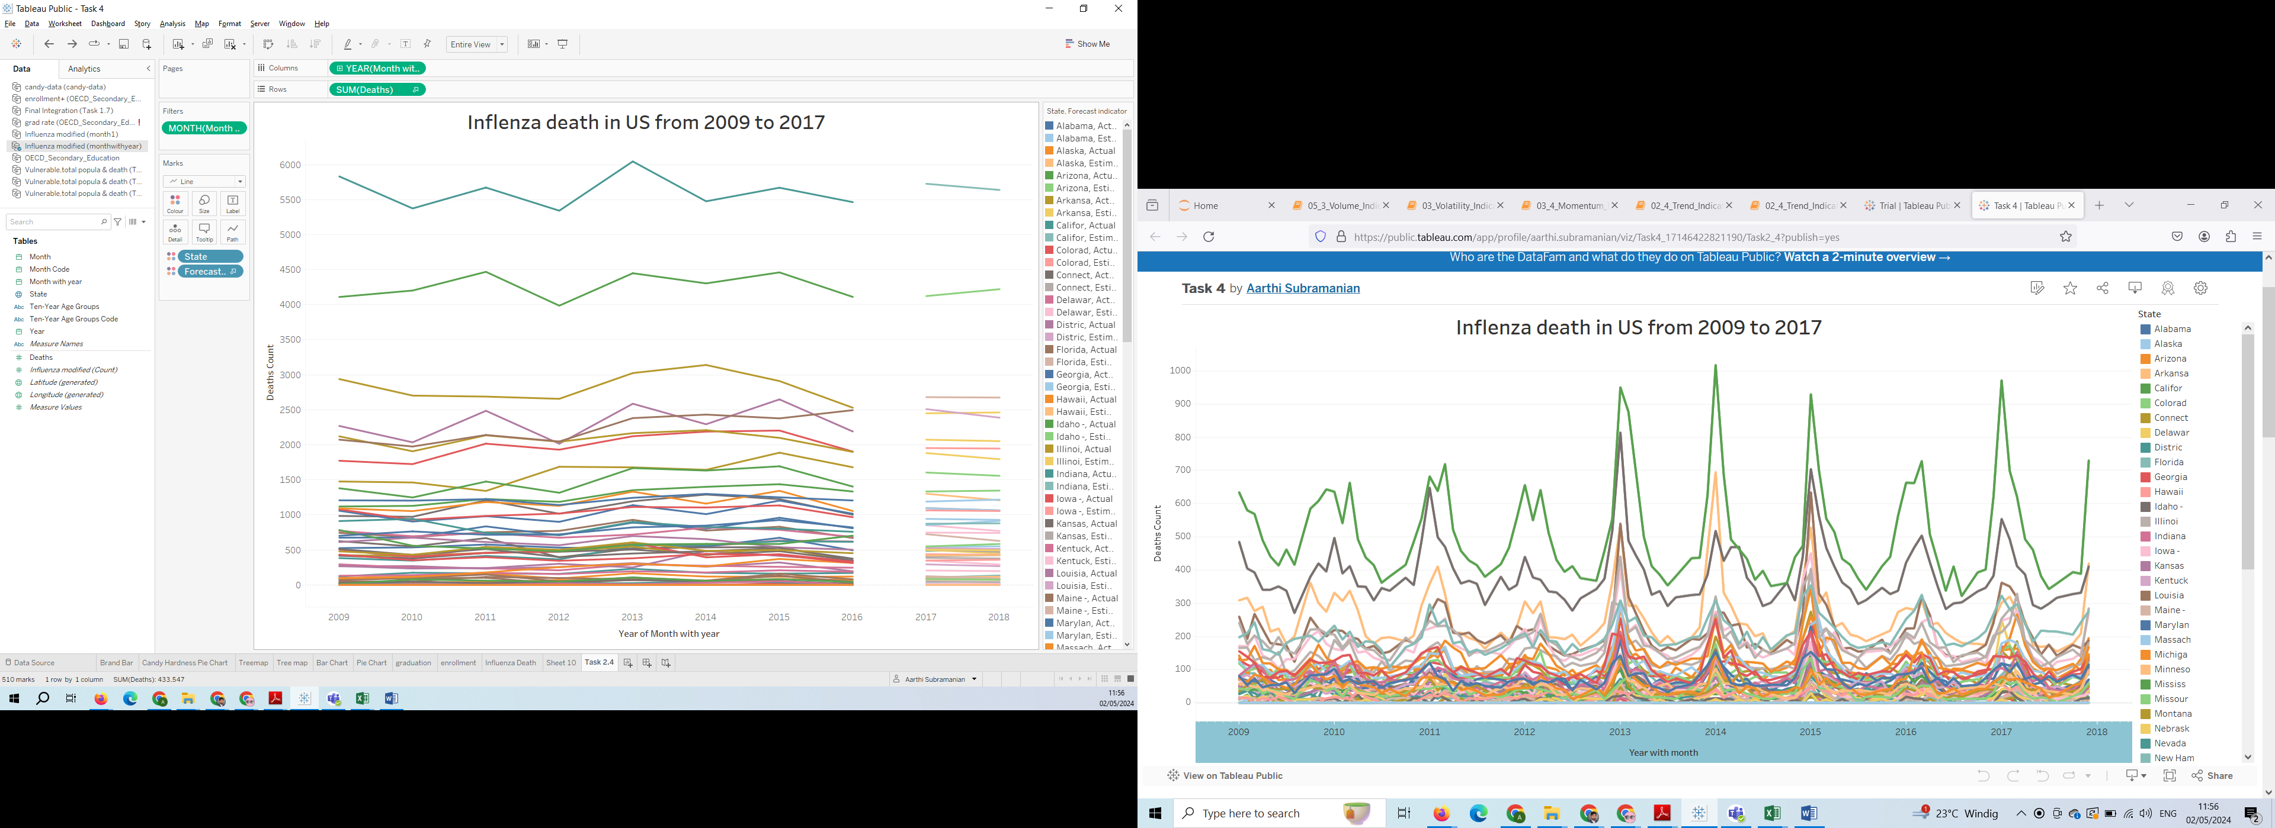

5. Grouped by regions of MidWest , NorthEast , SouthEast , SouthWest , West.

Link : <https://public.tableau.com/app/profile/aarthi.subramanian/viz/Task4_4_17146494400680/Task2_4?publish=yes>

